**Azure Application Insight:**

When we create app service, in monitoring tab we have option to create application insight.

In single Application insight we can add multiple application data.

Now it’s support linux also, If we have VM then we have to install SDK thare.

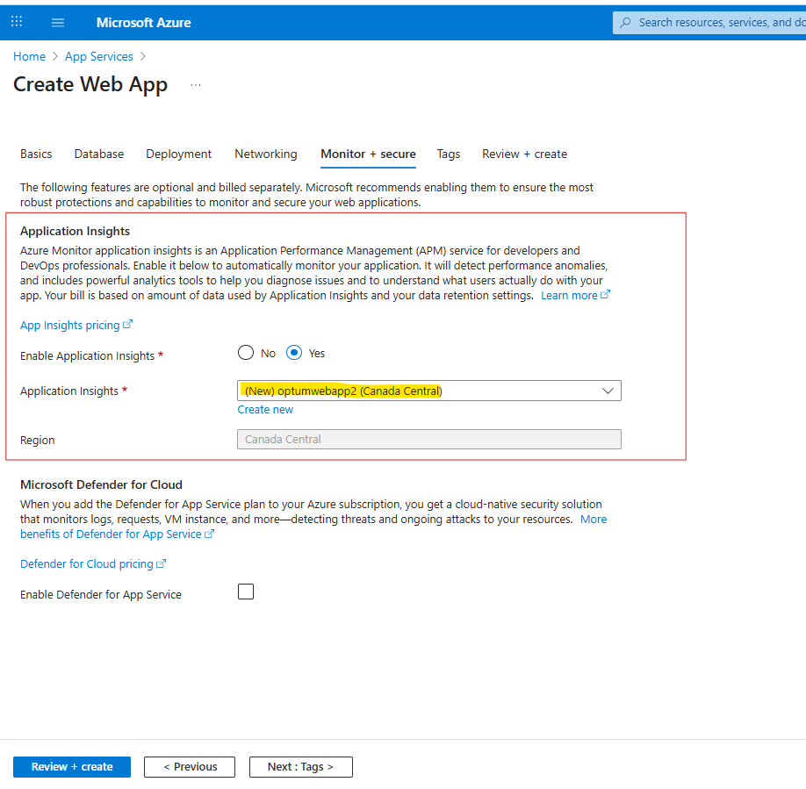

We can also create application insite service explicitly and then assign application.

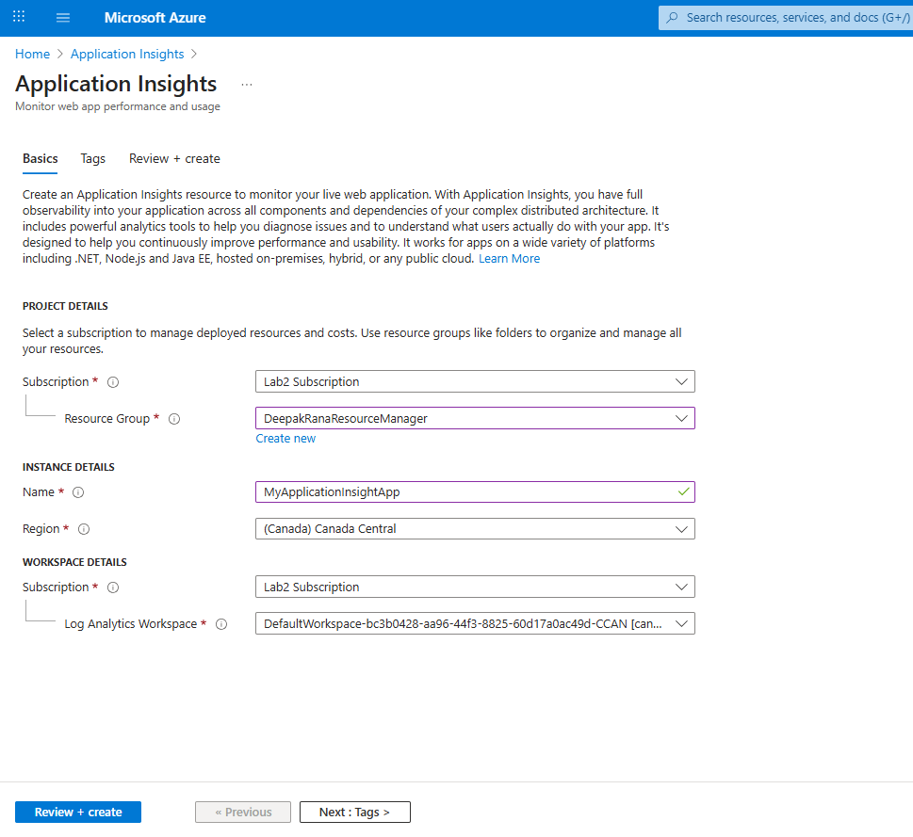

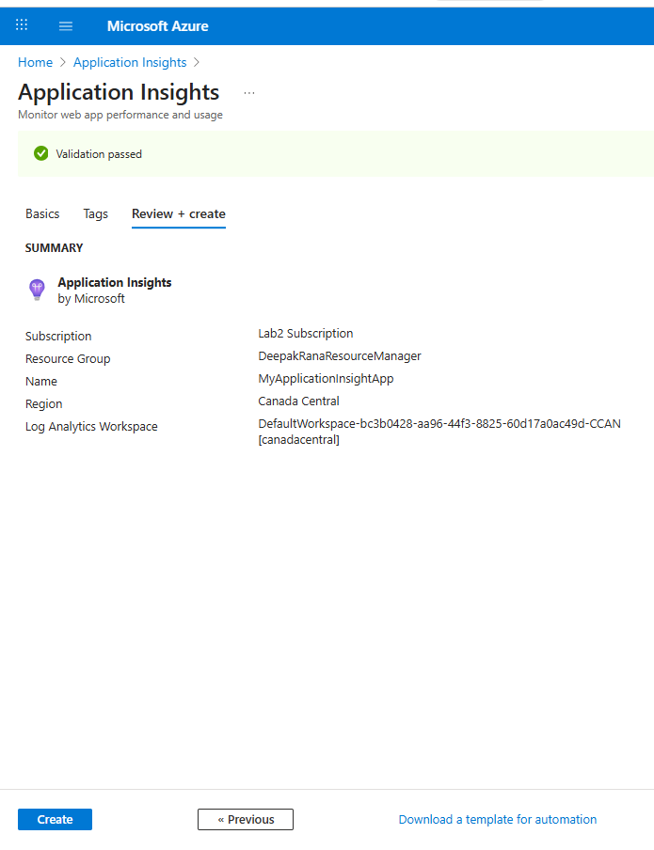

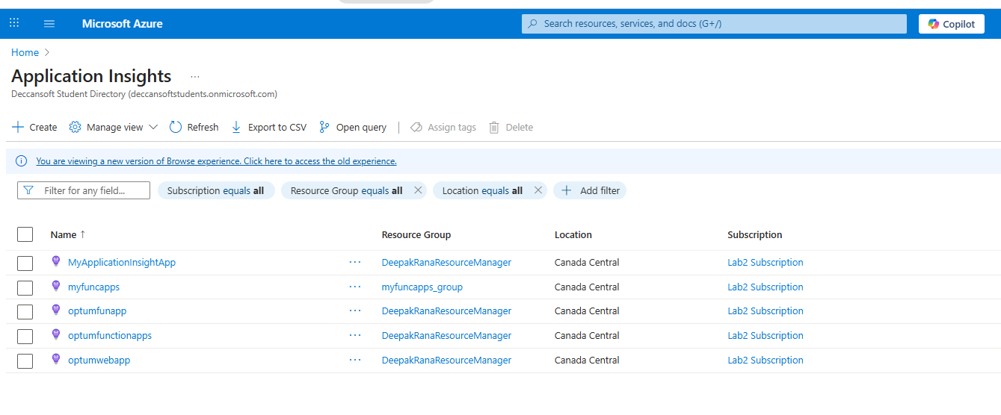

I have created a web app with out application insights

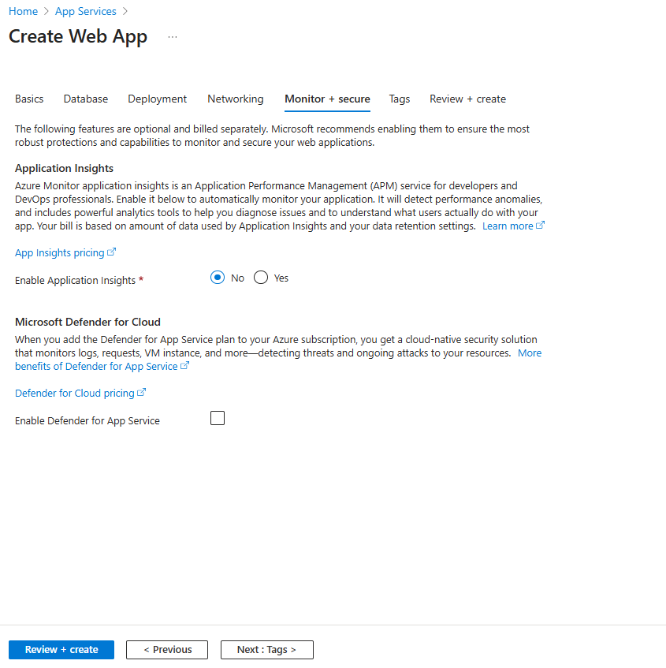

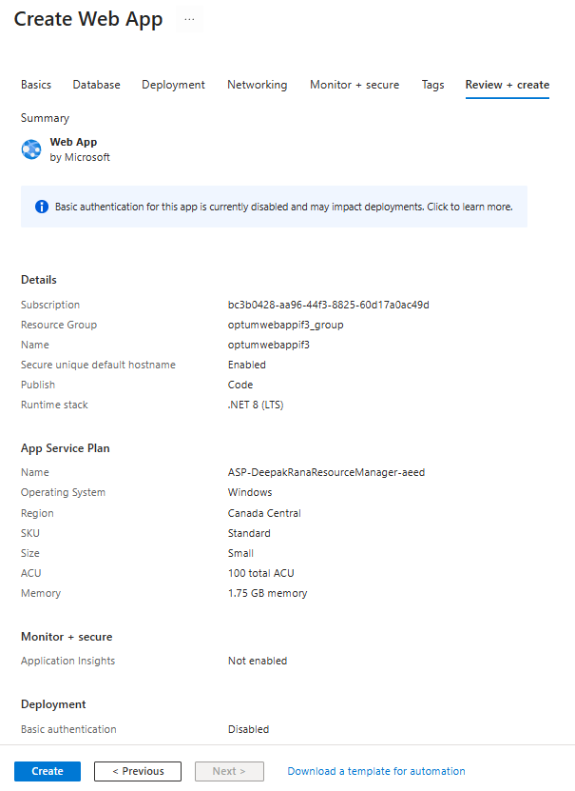

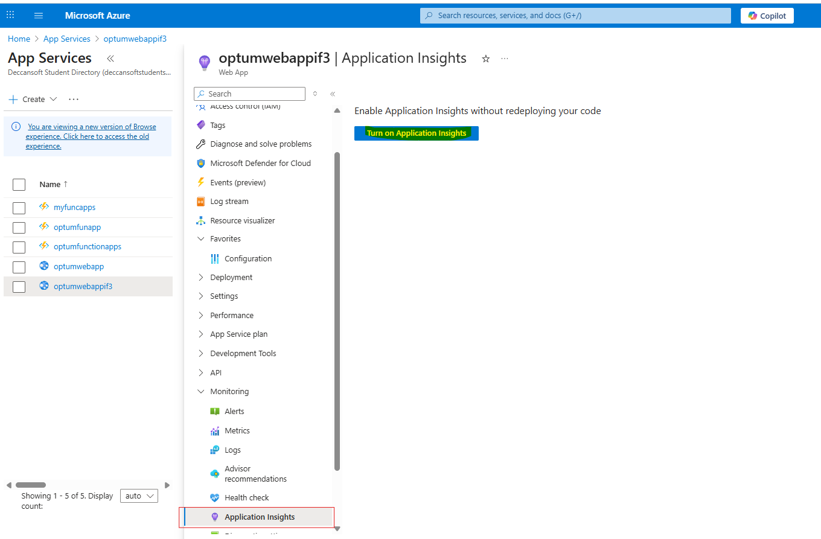

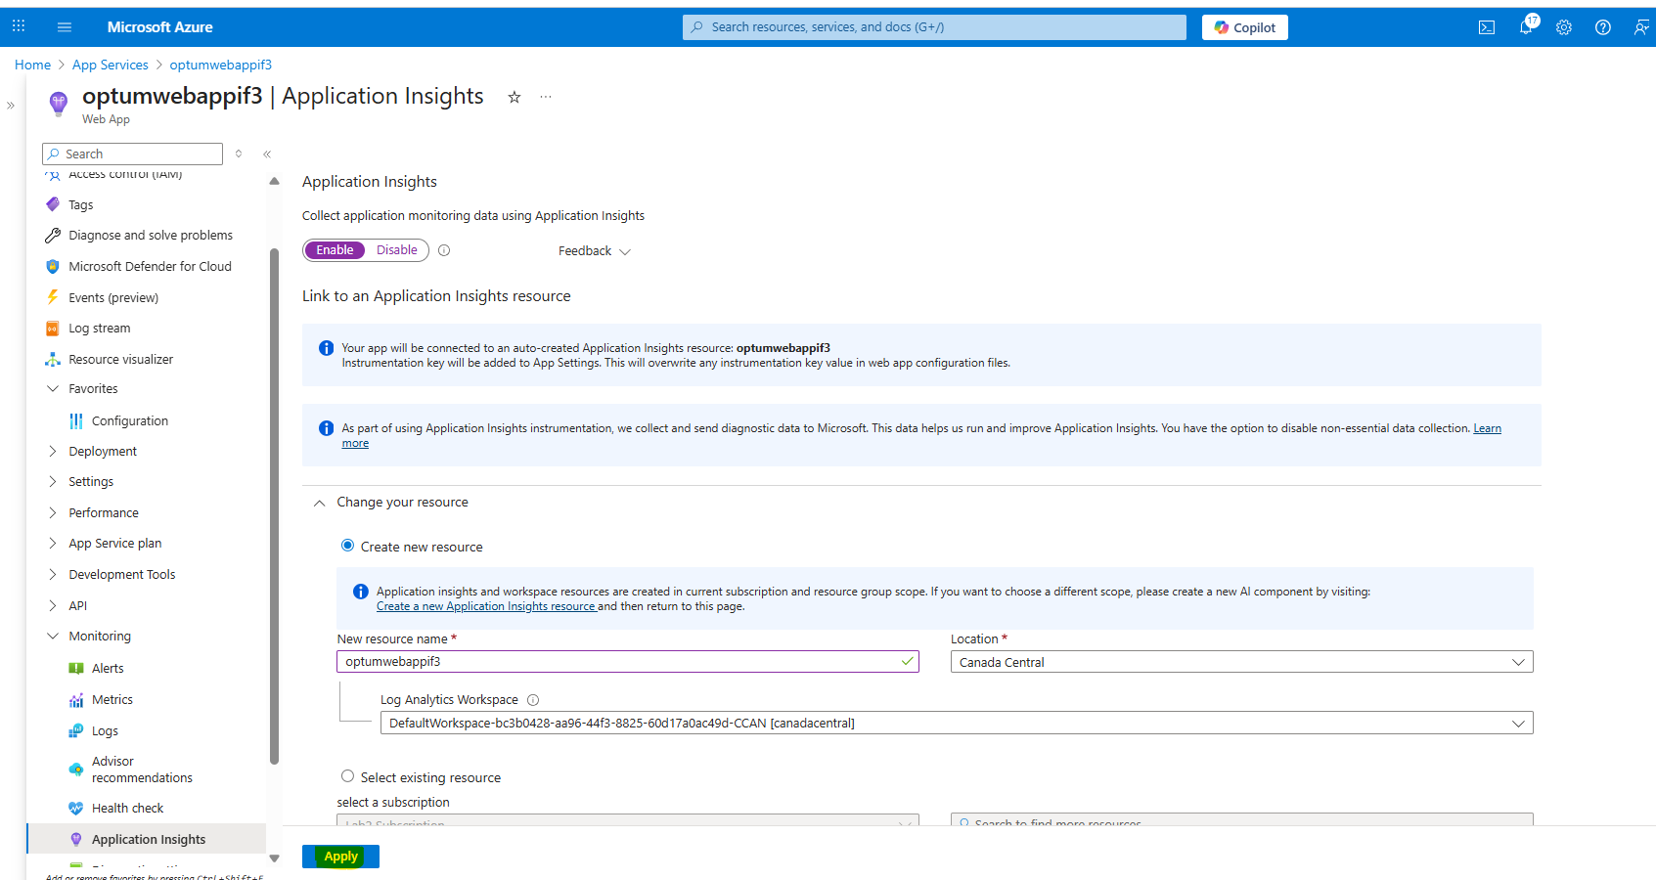

Once we click on apply it automaticly created a Appliation Insight app

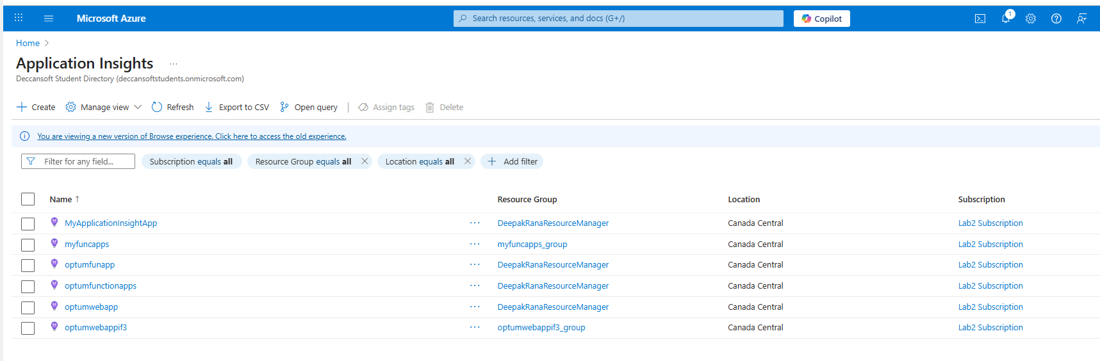

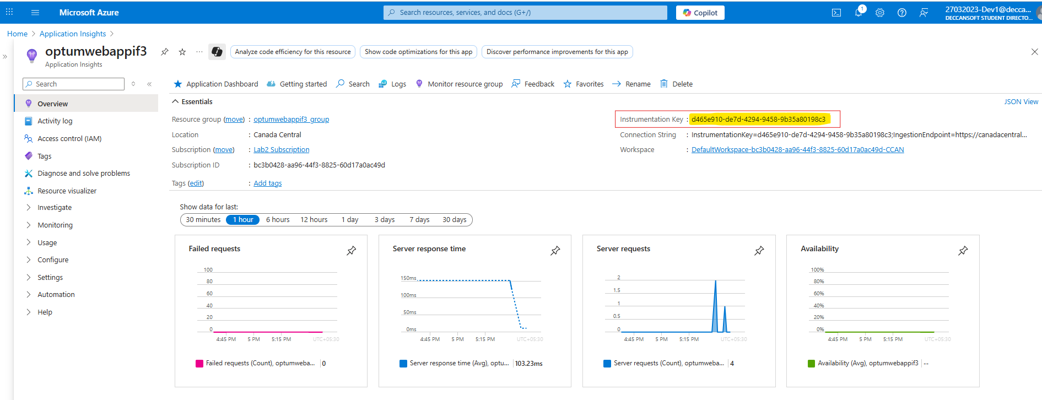

Now we need to assign this application insight to app service with instumentation Key.

**Instrumentation Key: “**d465e910-de7d-4294-9458-9b35a80198c3”

**Connection String :** ”InstrumentationKey=d465e910-de7d-4294-9458-9b35a80198c3;IngestionEndpoint=https://canadacentral-1.in.applicationinsights.azure.com/;LiveEndpoint=https://canadacentral.livediagnostics.monitor.azure.com/;ApplicationId=ca4394fe-3275-4ac3-af6a-0a26be296b64”

Let’s go to app service

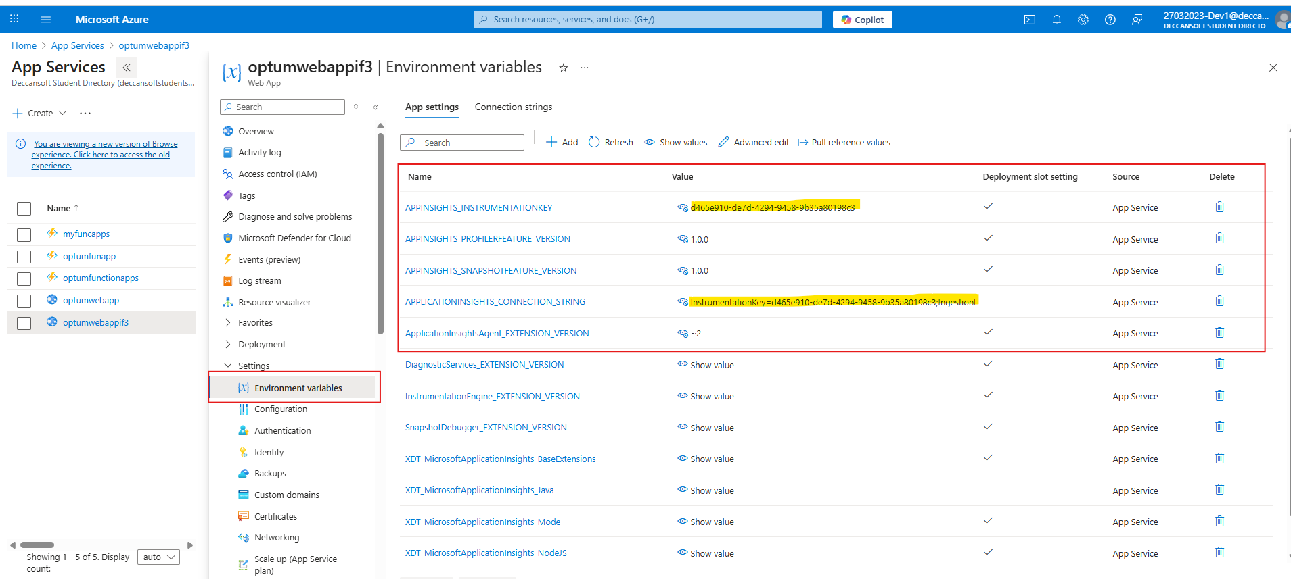

Next let’s install nuget package “Microsoft.ApplicationInsights.AspNetCore”

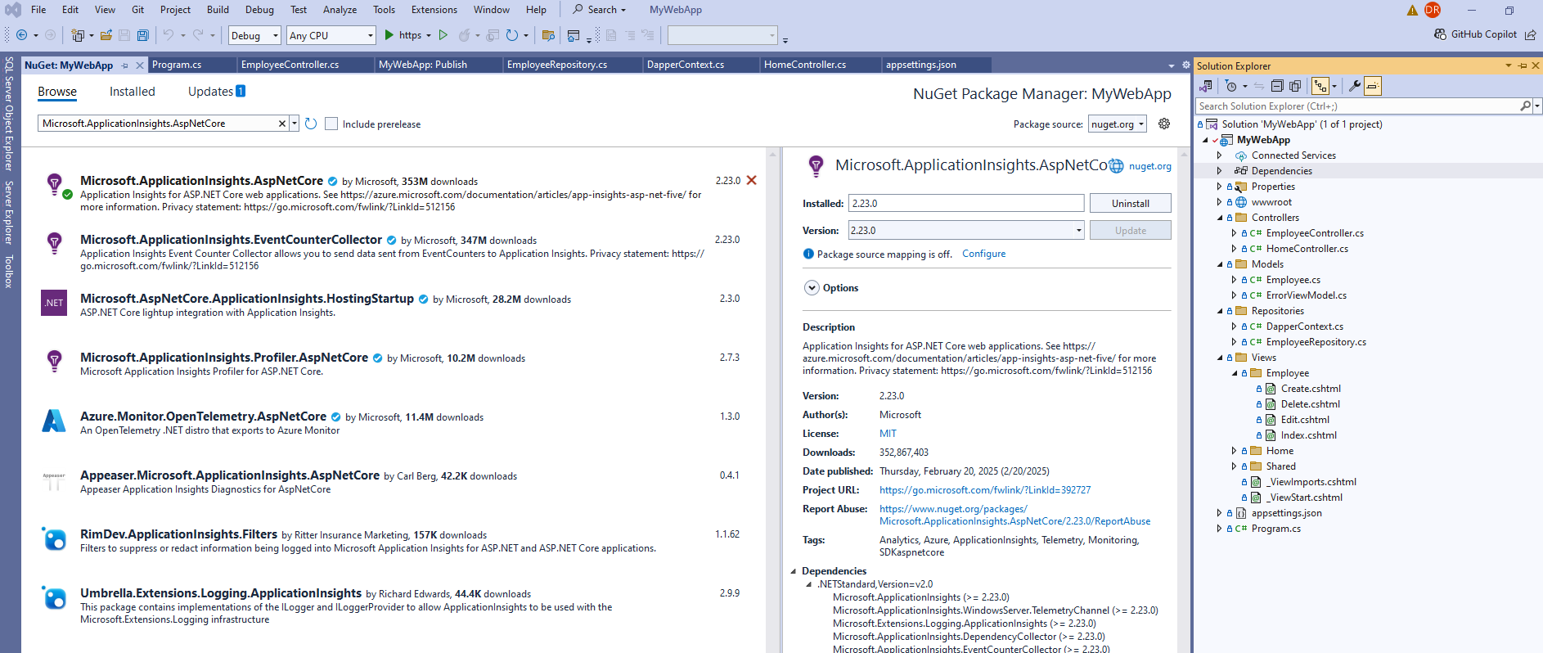

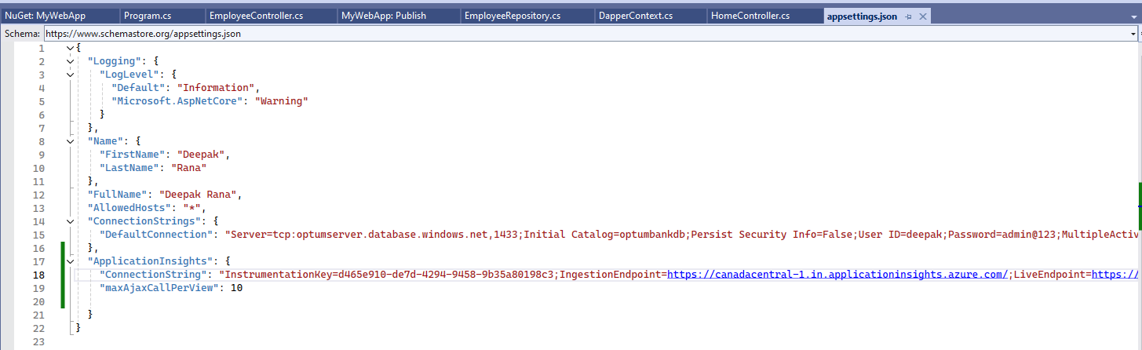

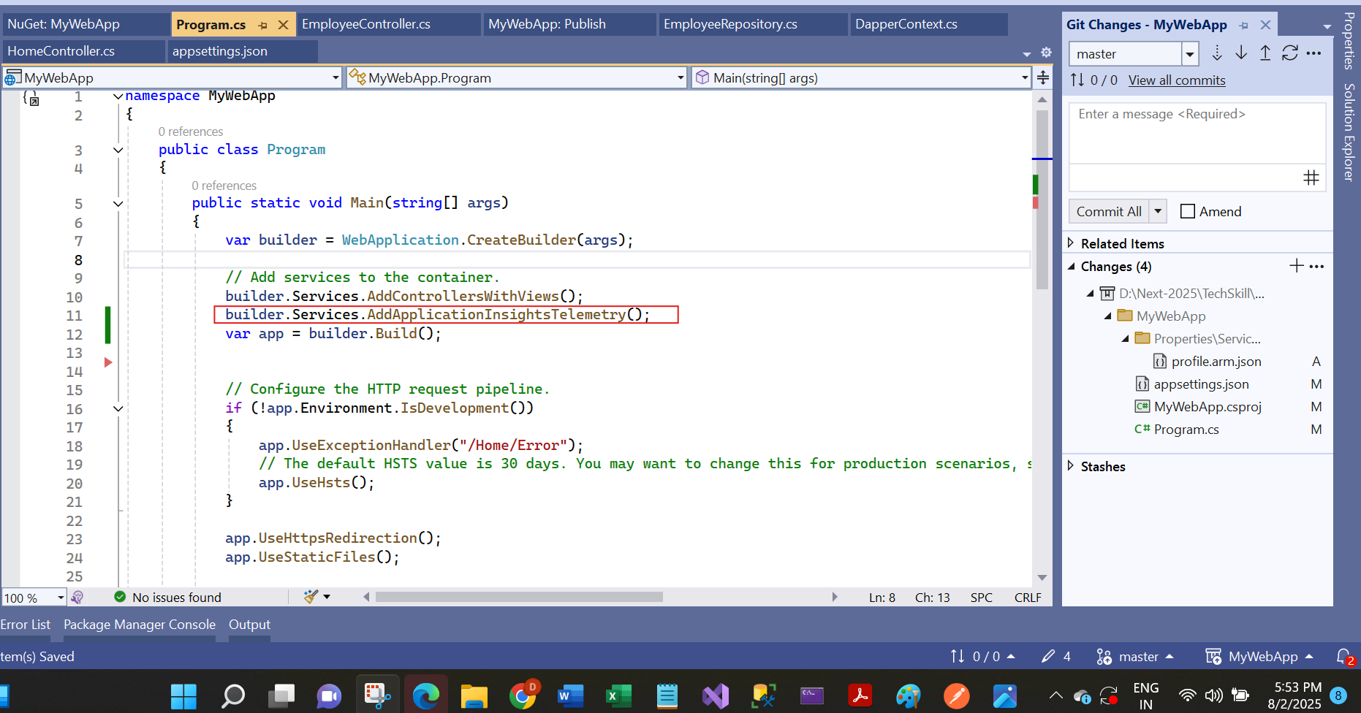

Now let’s deploy this app

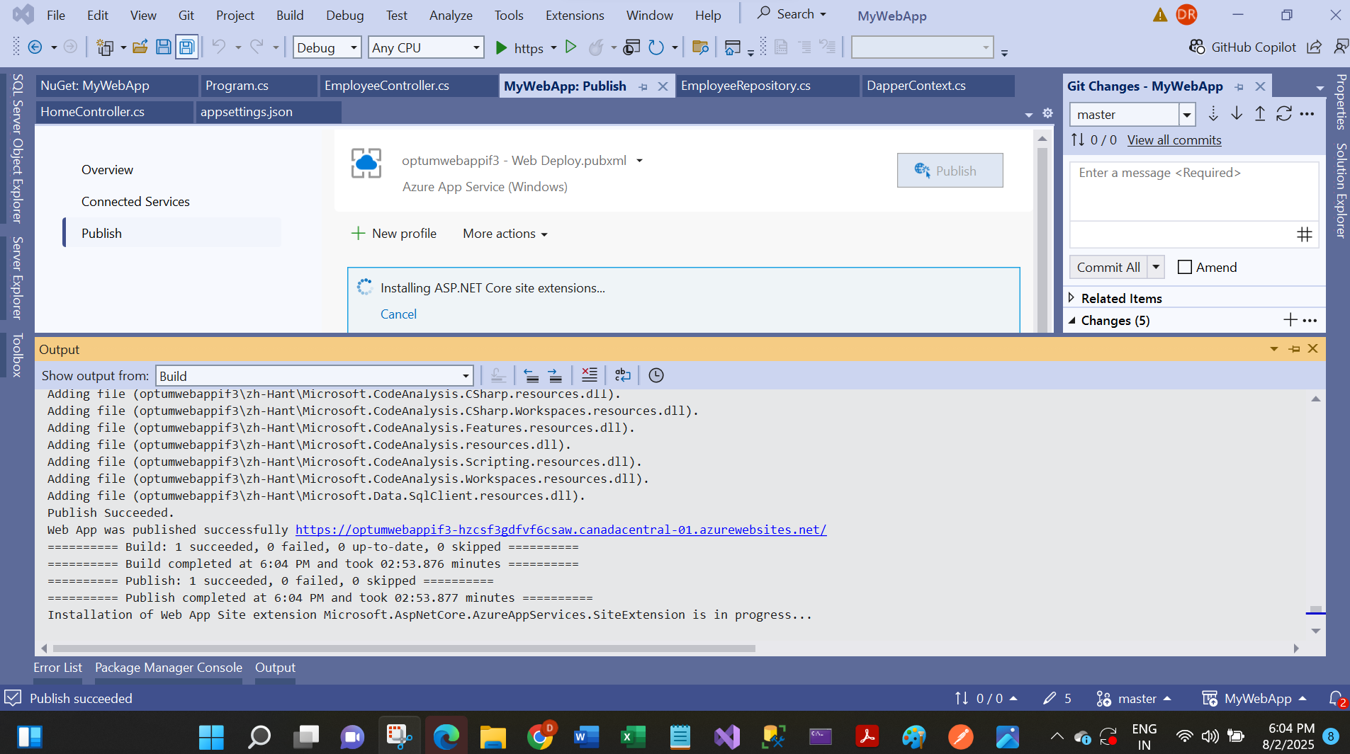

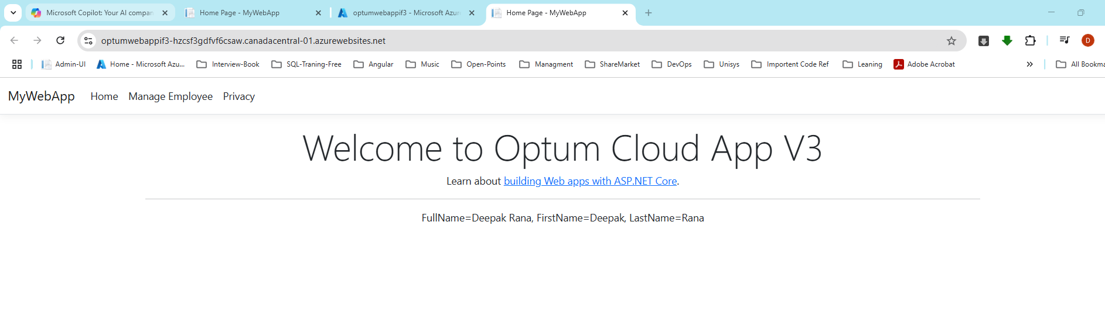

Let’s play with Application insite Live metrics

I have open 2 window I initieated multiple request on web application and live it is populated in Live metrics

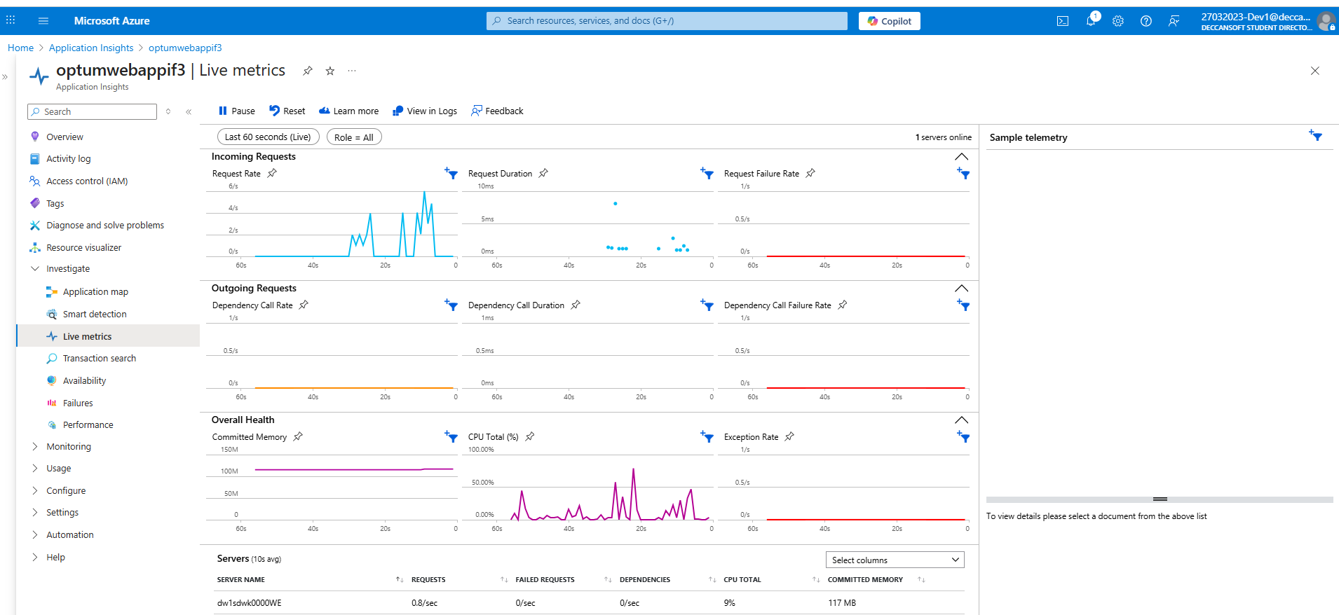

Intentiatnaly I have updated wrong connection string to replicate a exception scanariio with exter database (dependent service)

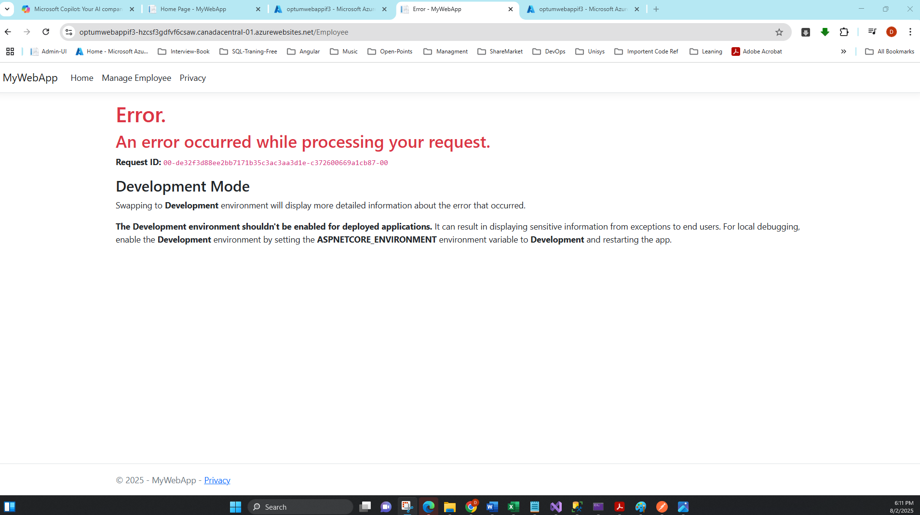

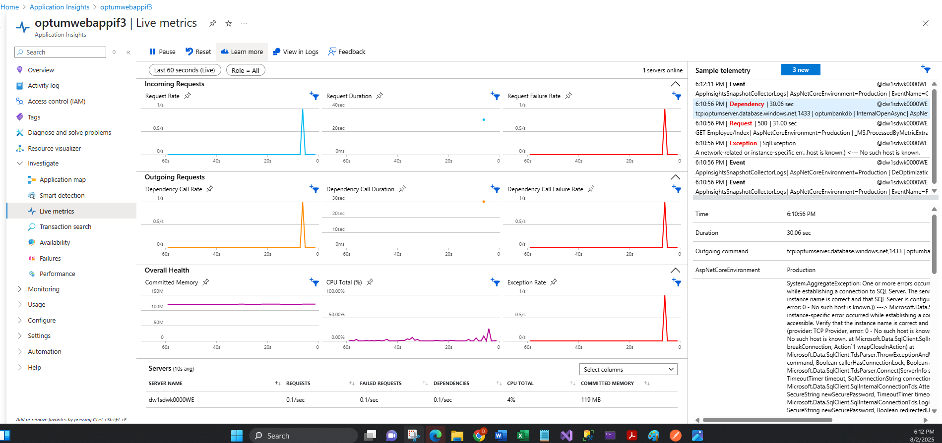

Then I requested a invalid ro(with invalid action name)

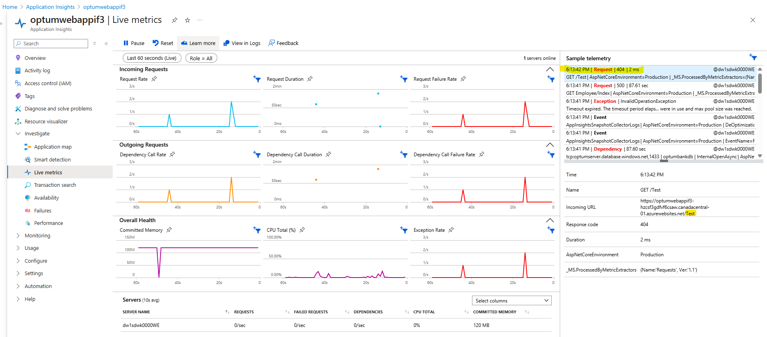

Failure tab

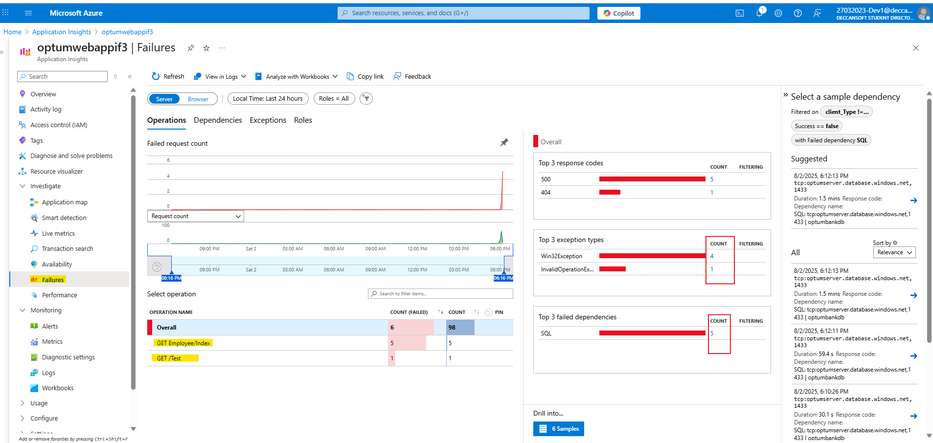

Once we click on any error It will redirected us to error detail page.

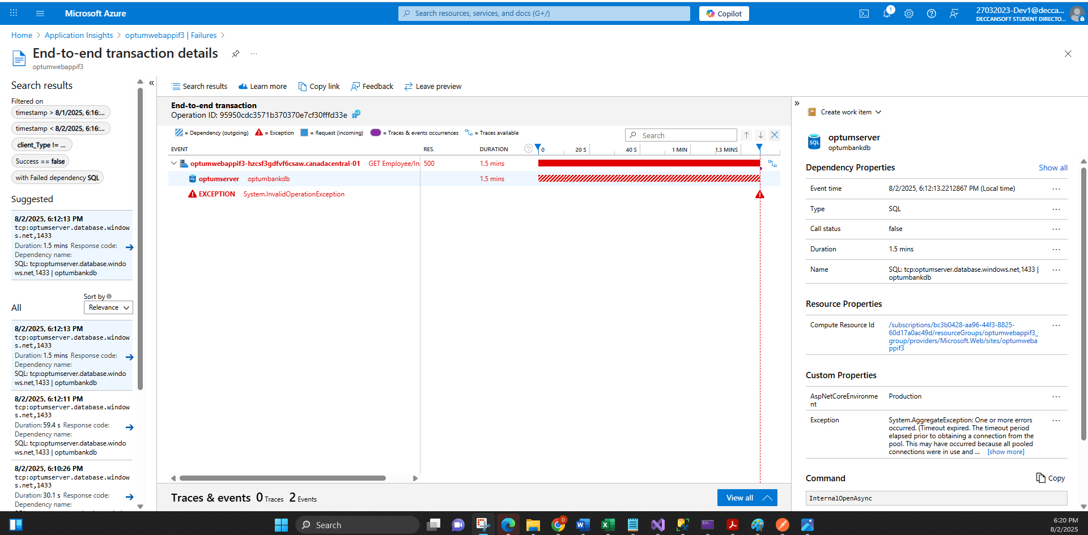

Once we lick on this link it will take us to user flow

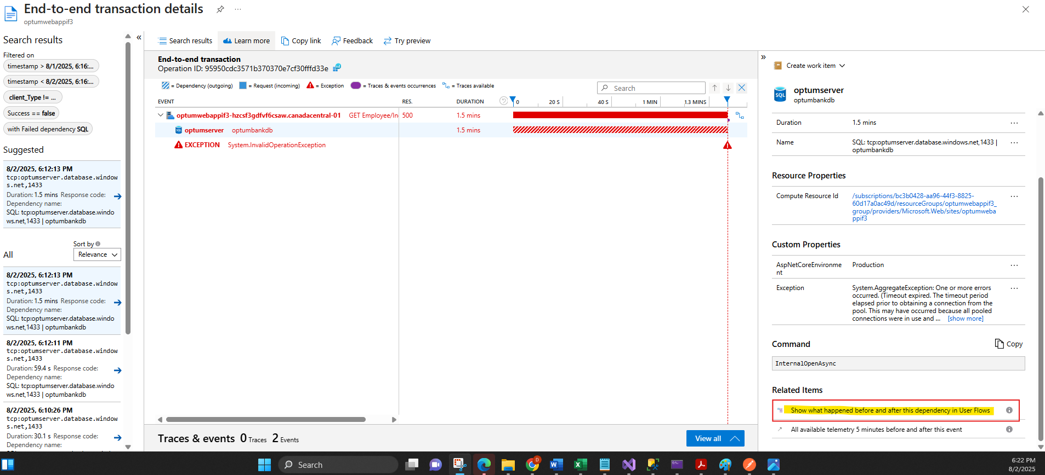

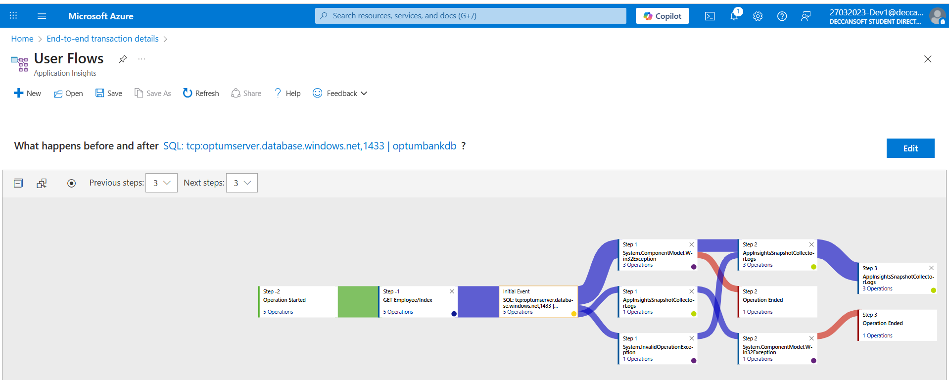

Availlability

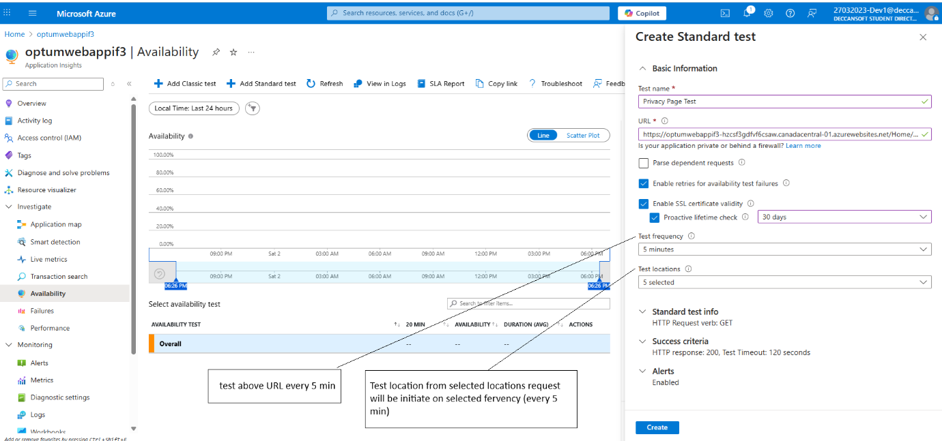

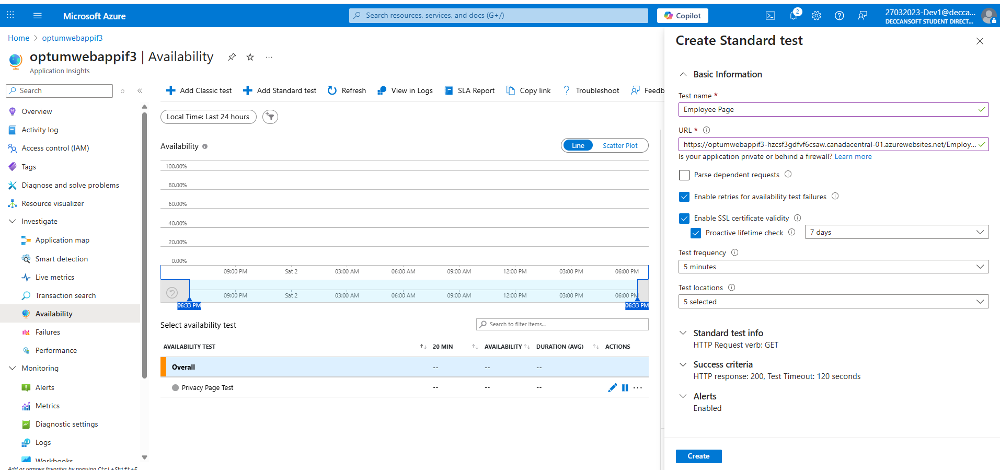

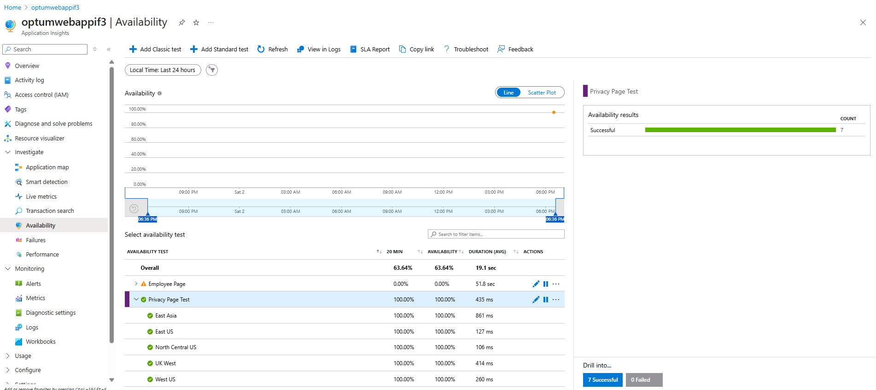

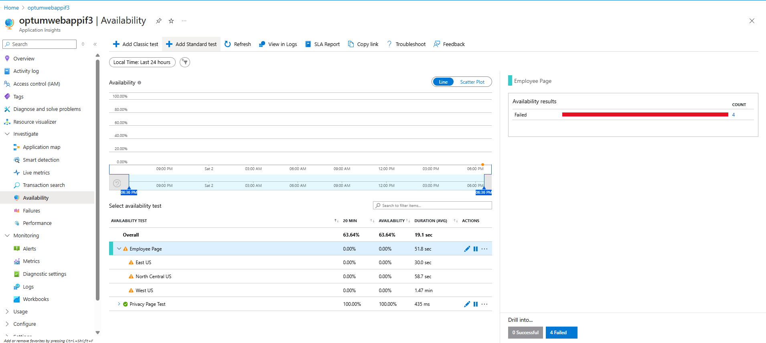

Application map

This one is my favrit , It will show all dependnet resources/ services on our application and what’s there health status.

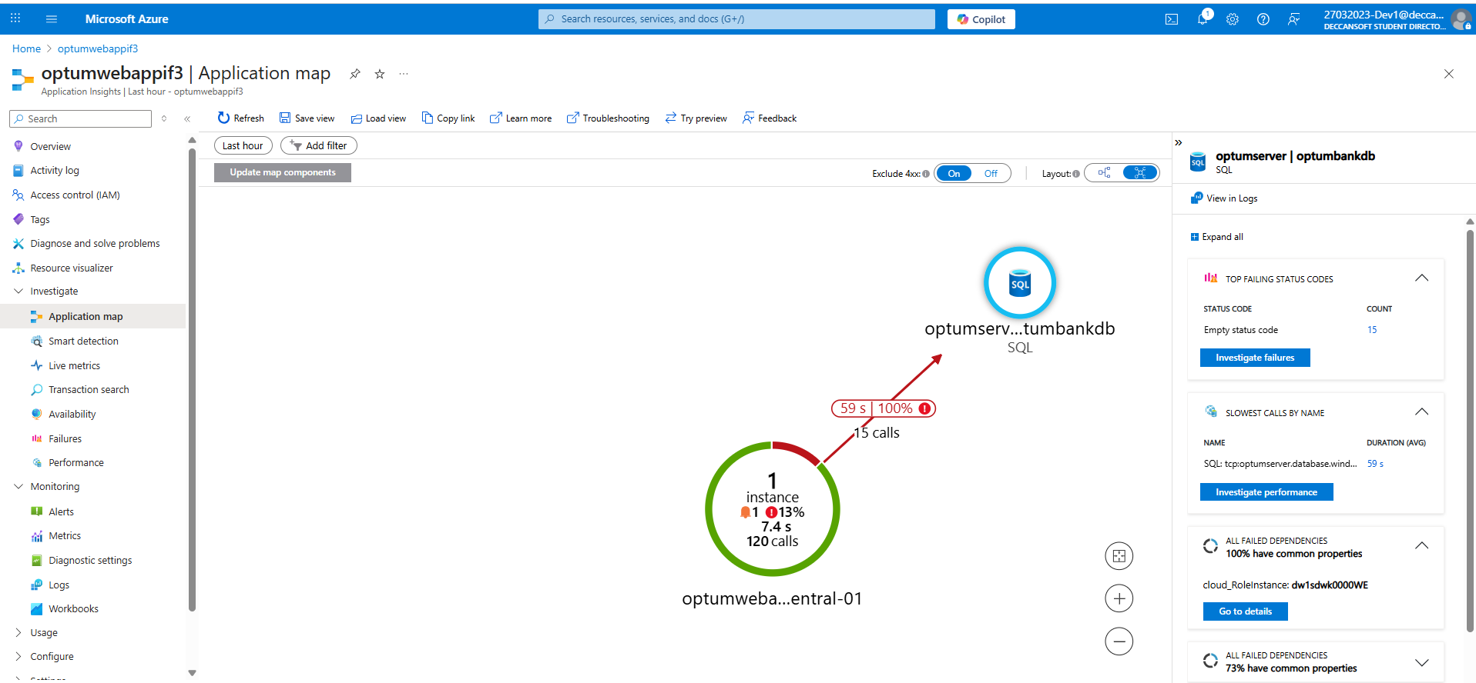

Performance

